Name: Saad
Roll no: 076
Section: BSAI-3B
Subject: A.I (Lab)

Lab 5: Adversarial Search: Minimax & Alpha-Beta Pruning
Lab Task(s)
1. Trace the supplied tree by hand using Minimax.
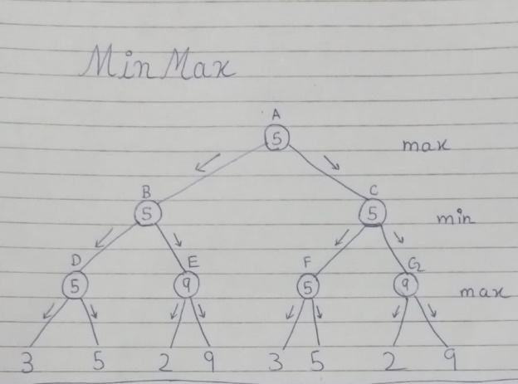
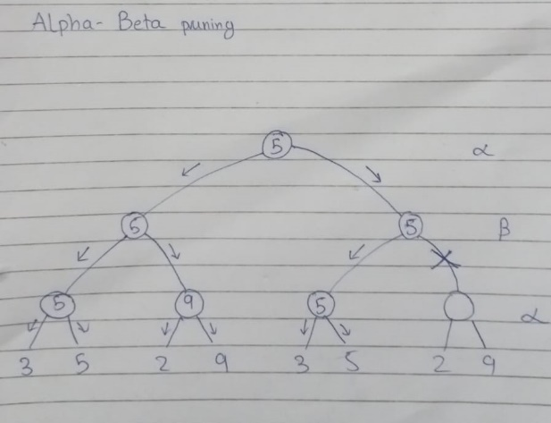

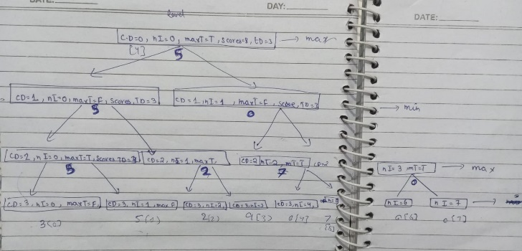

2. Add a leaf-evaluation counter to both algorithms.
Answer:
I added 2 variables (alpha_beta_counter , minimax_counter ) for both alpha-beta pruning and minimax. I initialize both of them to 0. After that I use the global keyword inside the functions of both alpha-beta pruning and minimax so we can use these variables both inside and outside of the function.
After that I added ( alpha_beta_counter += 1) and( minimax_counter +=1)
Inside both of the function’s condition of depth==tree_depth, when this condition is reached the index on that node or you can say that specific leaf is visited. And every time a leaf gets visited the counter adds 1 inside it meaning it is counting how many leaf are visited to find the answer for both of the functions.
After that we again initialize both of them to 0 inside the loop (If you have multiple scores this will do a fresh restart count for different scores.)
At the end we print both of the counters as
print("Number of evaluated leafs = ",minimax_counter) # for minimax visited leaf
print("Number of evaluated leafs = ", alpha_beta_counter) # for a-b pruning leaf

3. Reorder branches and observe how pruning changes while the Minimax value remains the same.
Answer:
I change or reordered the branches separately so we can observe how pruning changes while the Minimax value remain the same.
The given complete score is (scores= [3, 5, 2, 9, 3, 5, 2, 9]), Its given in a list so by have multiple list with different reorder branches and to identify which on is original and which one is reordered I change the list() into a dict().
scores = {
"original_order": [3, 5, 2, 9, 3, 5, 2, 9],
"reordered_1": [5, 3, 9, 2, 5, 3, 9, 2],
"reordered_2": [2, 9, 3, 5, 2, 9, 3, 5]
}
Is this way we can have track of which order is being executed.
Output:
The optimal value for alpha-beta pruning original_order = 5
Number of evaluated leafs = 6
The optimal value for minimax original_order = 5
Number of evaluated leafs = 8

The optimal value for alpha-beta pruning reordered_1 = 5
Number of evaluated leafs = 5
The optimal value for minimax reordered_1 = 5
Number of evaluated leafs = 8

The optimal value for alpha-beta pruning reordered_2 = 5
Number of evaluated leafs = 8
The optimal value for minimax reordered_2 = 5
Number of evaluated leafs = 8

This is the terminal output of the written program. You can clearly see that in alpha-beta pruning and minimax the optimal value remains the same but the number of evaluated leaf are different for a-b pruning after changing the order but the order won’t effect the minimax evaluated leaf. Which means that the minimax always visit every single leaf with saving any time and alpha-beta pruning if it is in best case order which we can find using this formula:
$O\left(b^{d/2}\right)$.
Where O is the order b is the number of branches and d is the depth.

1.Short explanation connecting the result to the lecture learning outcome
Answer:
Minimax and alpha-beta pruning always gives you that same and best answer. In the code both functions gives value of 5. But alpha-beta pruning skips some not necessary visiting path and give the most optimal solution much quicker and efficiently.

2.At least one edge case, comparison, limitation or failure analysis
Answer:
Edge case:
The edge case of a-b pruning is that it is order sensitive. It only saves time and give quick response if the order is in best case, otherwise in the worse case order it visits every single leaf which is equivalent to minimax response which is slow not efficient and visit every single leaf.

Comparison Table:
Order | Minimax value | A-b pruning value | Minimax evaluated leaves | a-b pruning evaluated leaves
Original_order | 5 | 5 | 8 | 6
Reorder_1 | 5 | 5 | 8 | 4
Reorder_2 | 5 | 5 | 8 | 8

As comparison table shows that both are giving optimal solution but you can clearly see that a-b pruning can give optimal solution just by visiting 4 leaves in Reorder_1. It shows that a-b pruning is far more efficient that minimax but only in best case order.

Limitations:
both of the function work on the condition of (current_depth = target_depth)
in dynamic games you target depth keeps changing with every move you play. So, this is not compatible for that.

3.Practical Reflection and Real-World Use:
Connect four, checkers, and chess engines use alpha-beta search.

